Download PyCharm

For Linux

<https://www.jetbrains.com/pycharm/download/#section=linux>

For Windows

<https://www.jetbrains.com/pycharm/download/download-thanks.html?platform=windows&code=PCC>

Python data type:

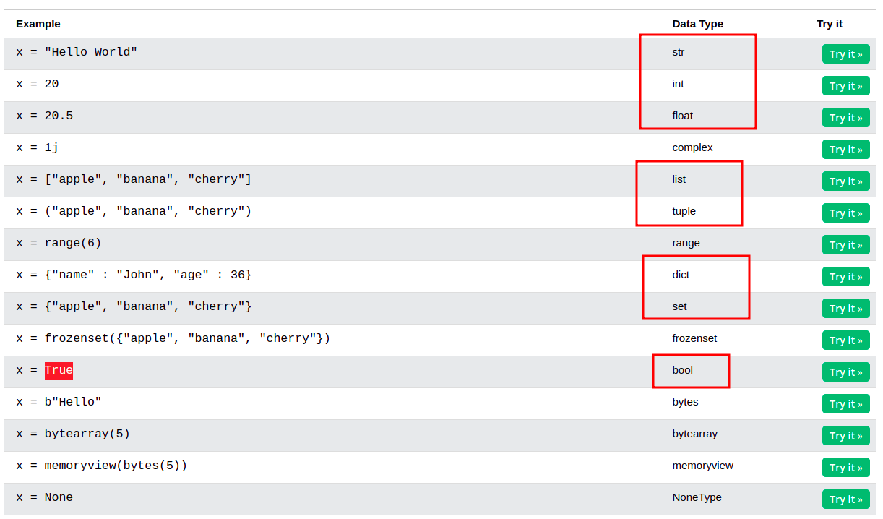

Ref:

https://www.w3schools.com/python/python_datatypes.asp